* We can server dynamic pages to users with template engine. 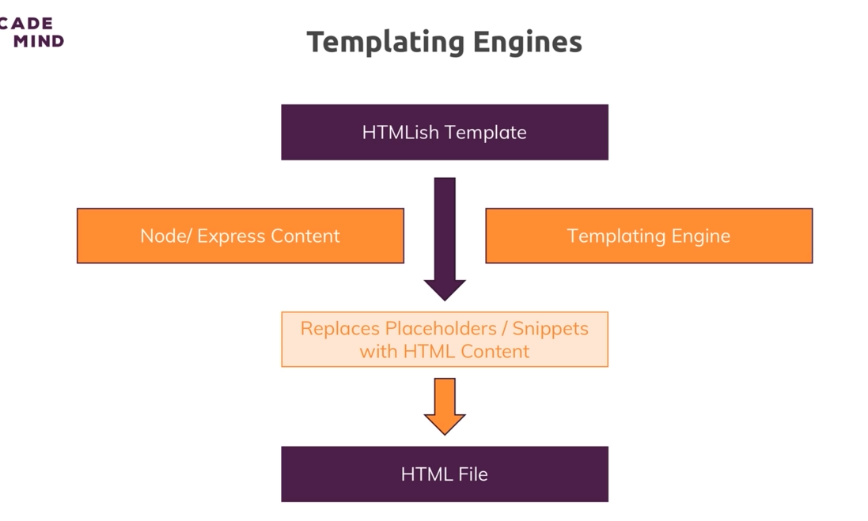

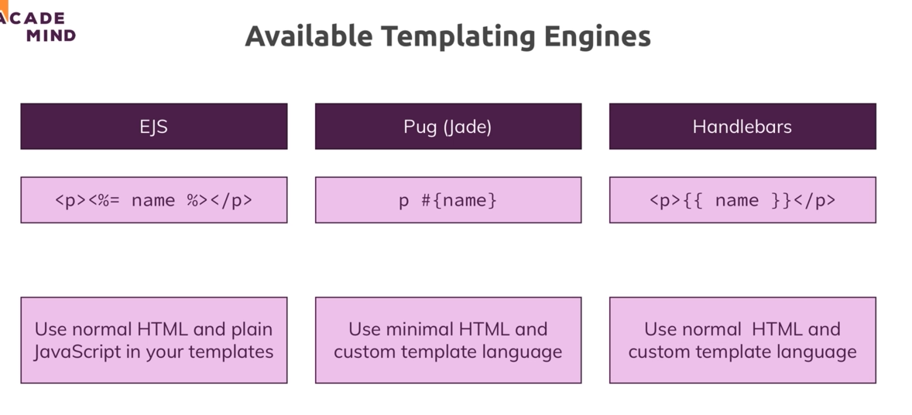

* **Pug/jade** probably the best scripting template since it have minimal html also have layout system , with javascript logic in the template. I wont use it for now since don’t want to learn new html.
* **Handlebars** use normal html language , but cant use javascript logic in the template, only data. Probably to avoid confunsion, well I wont use it either.
* **Ejs**  is the one im gonna use, it uses html syntax, supports javascript as well, only drawback is it don’t have layout. But we can overcome this by using partial include.